Data Analysis and Algorithm

Practical 4

Implement Hiring Problem and analyze its

complexity.

Date.: 16-09-21

Name – Yash Vasudeo Prajapati

Rollno - 022

MSc. Computer Science

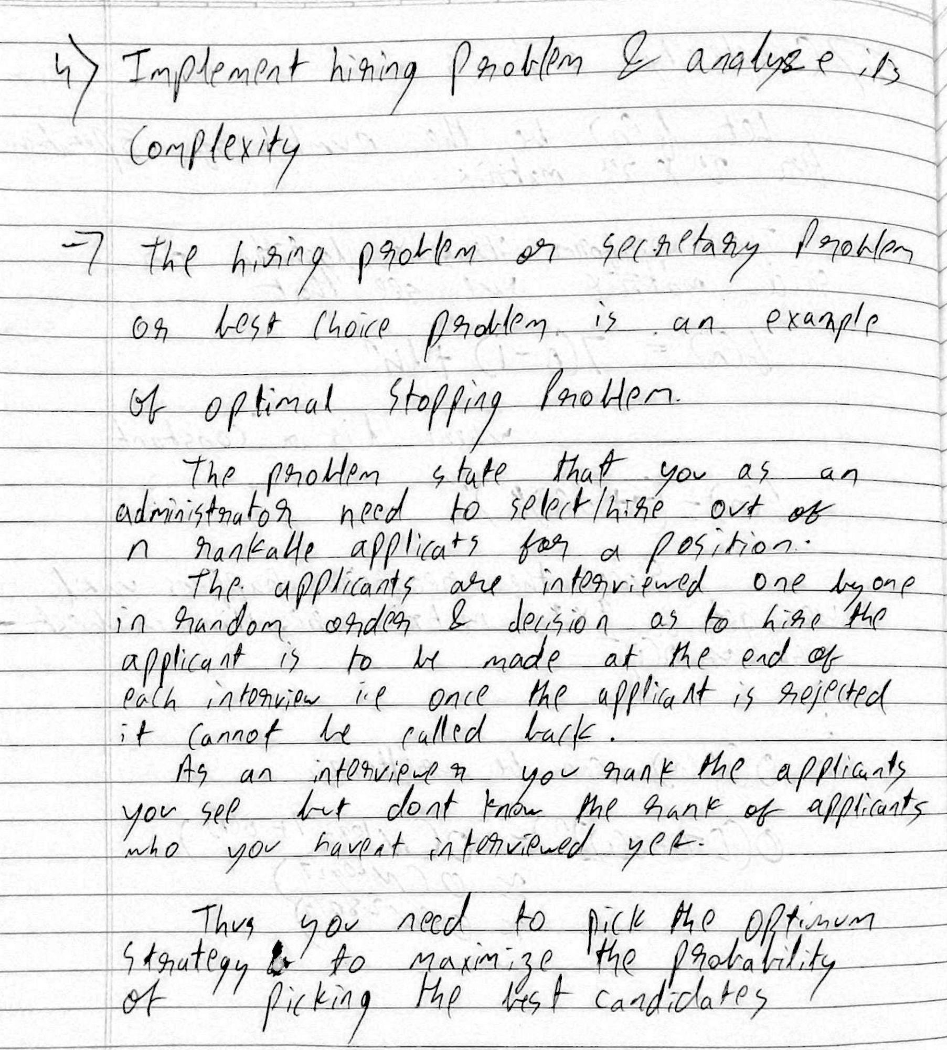

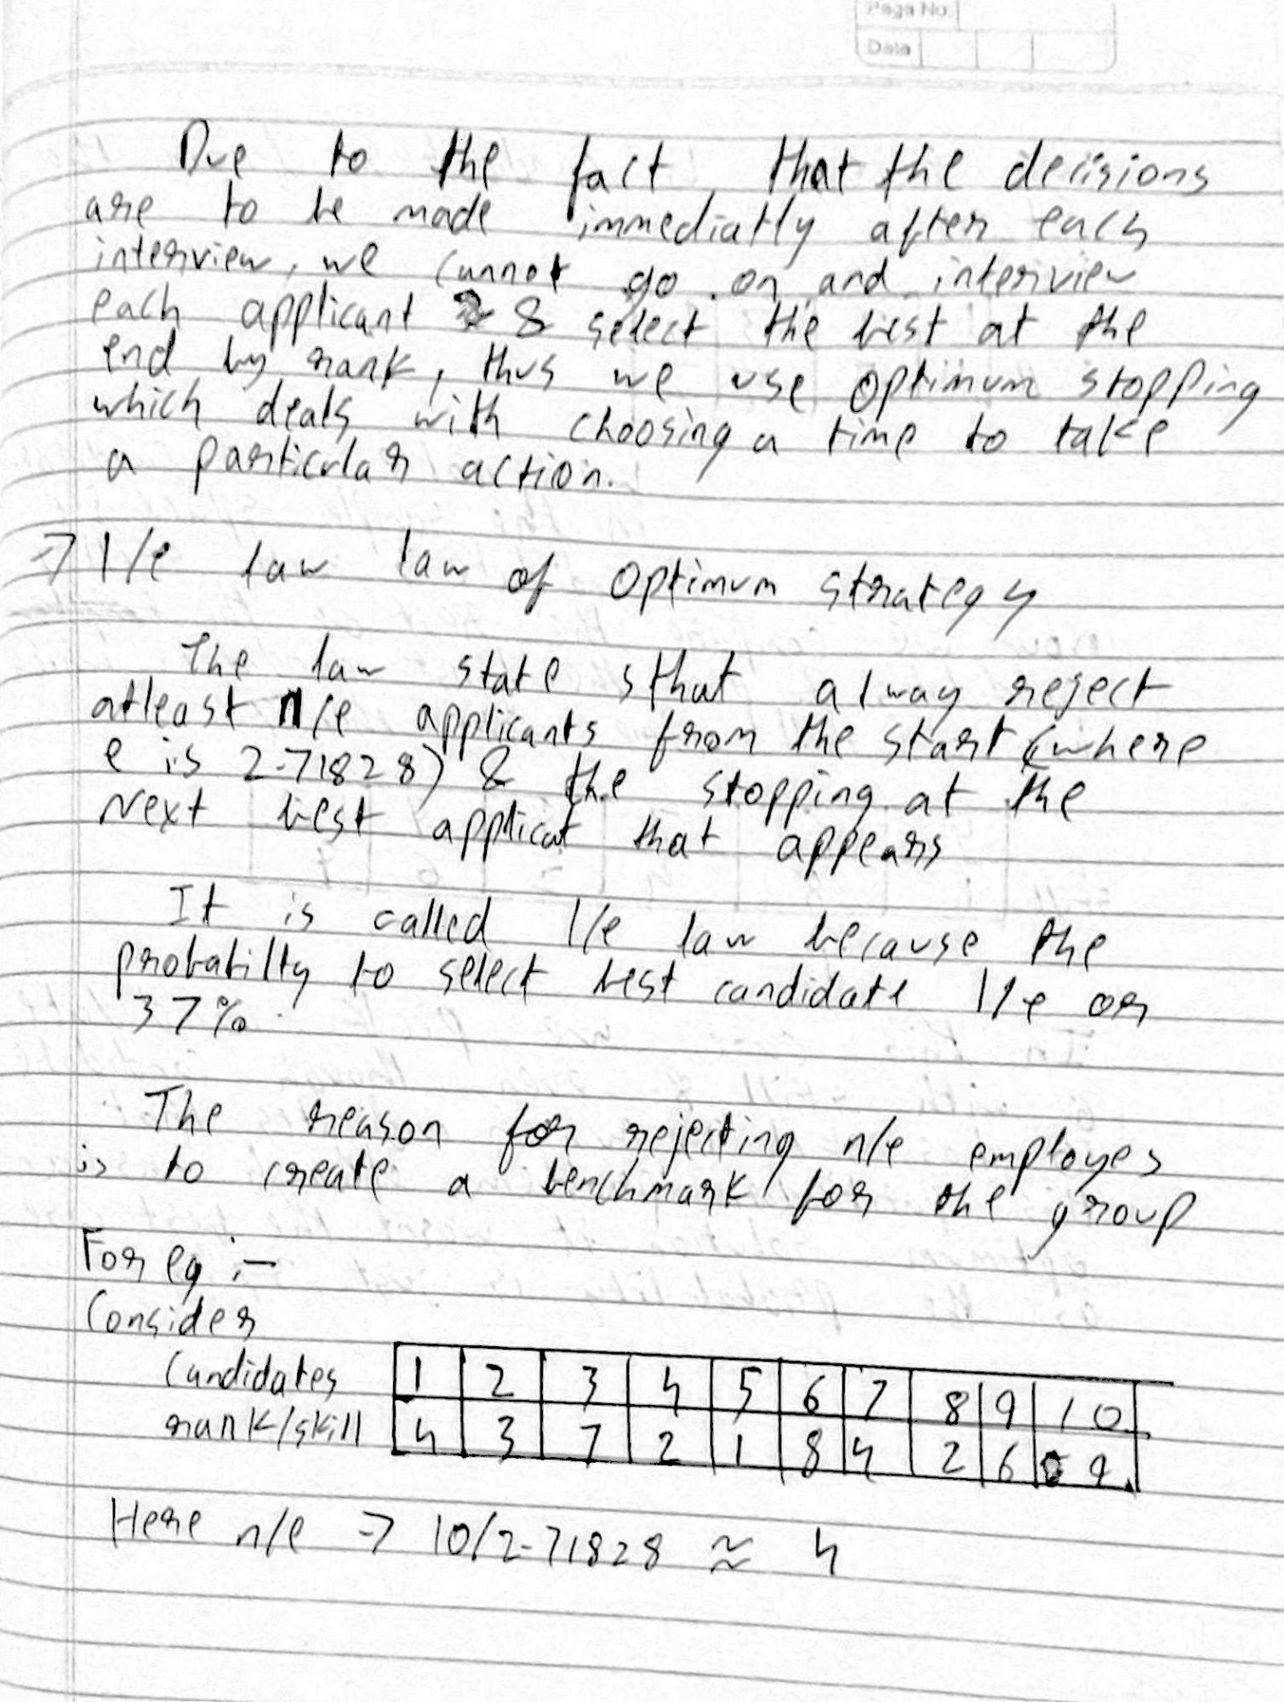

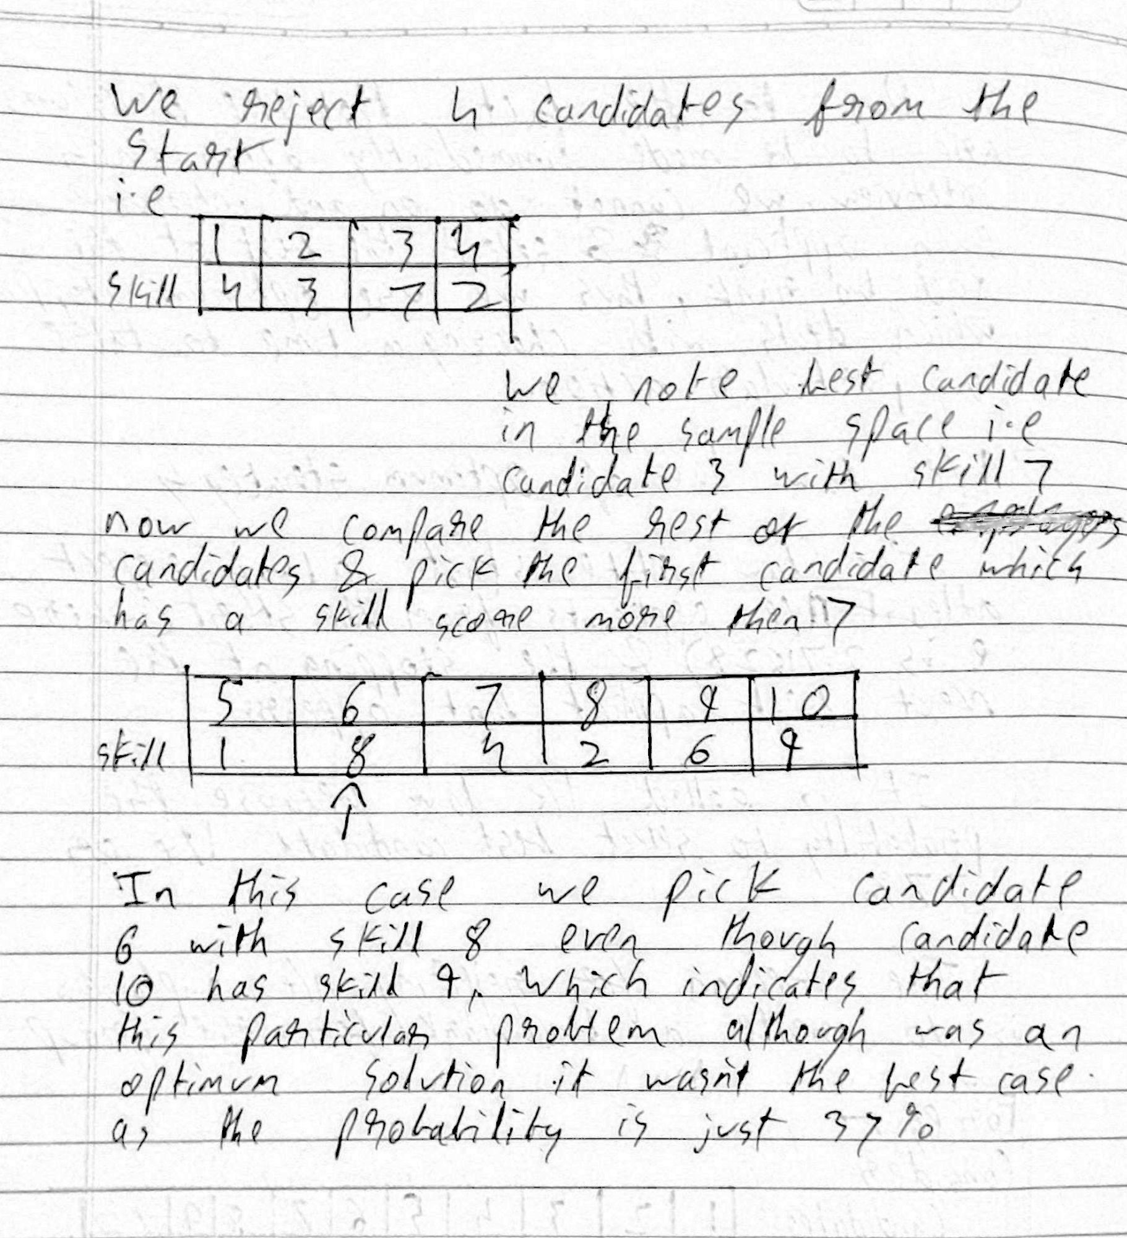

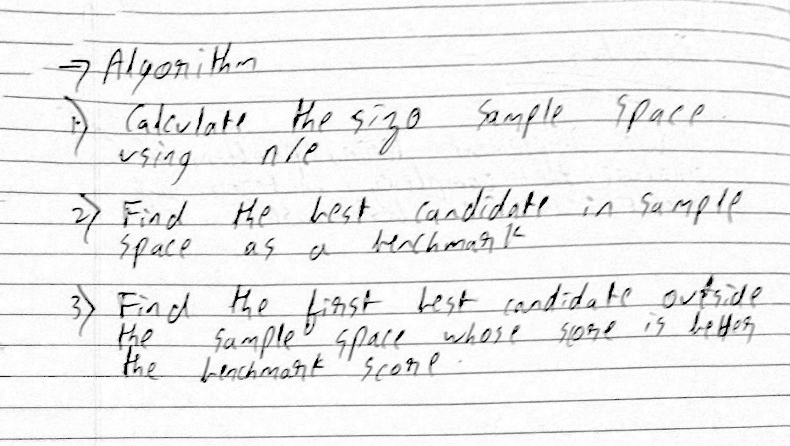

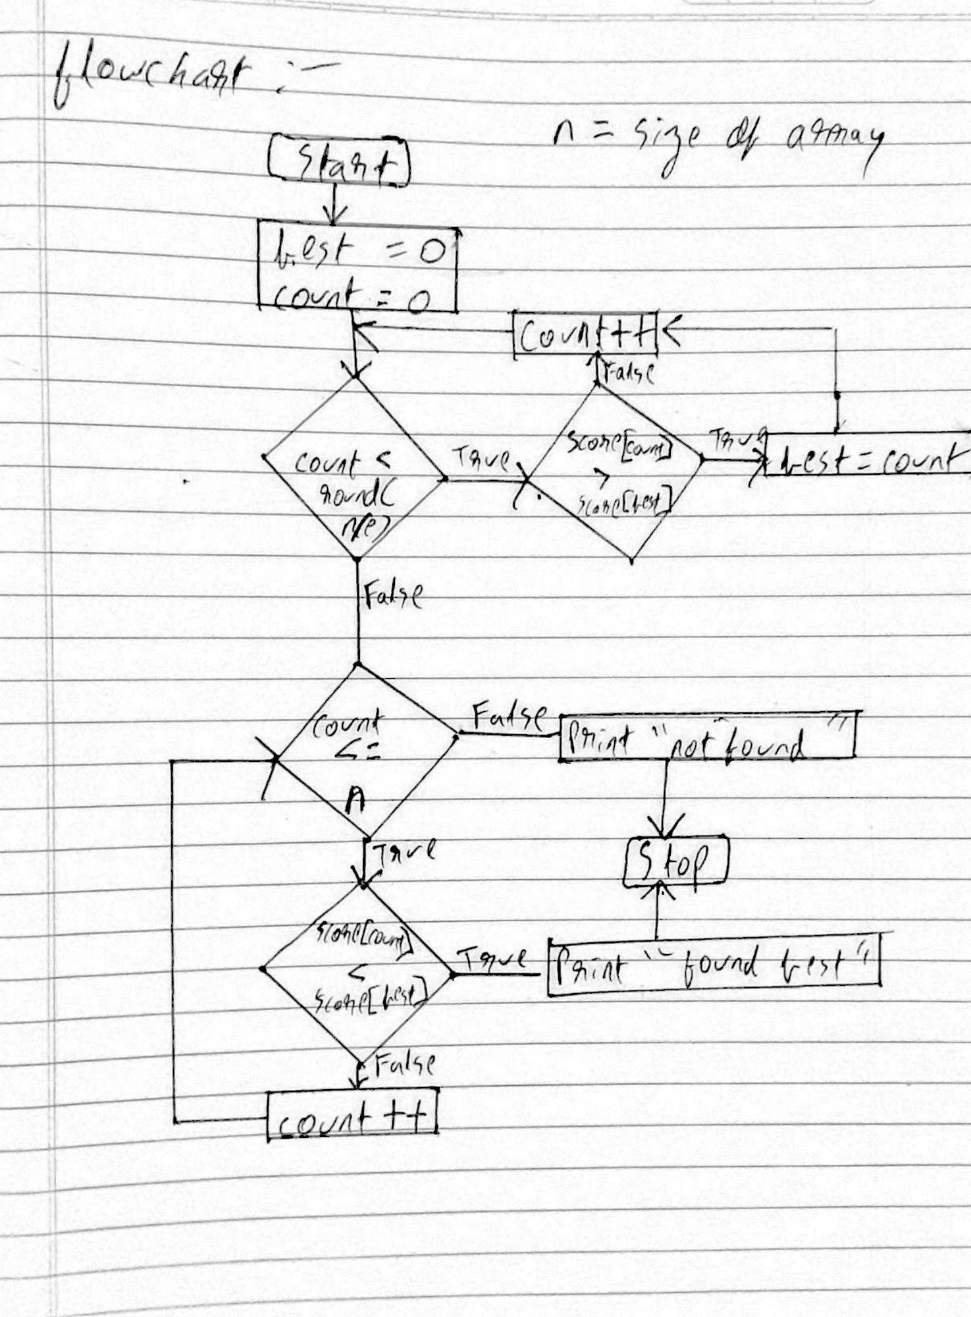

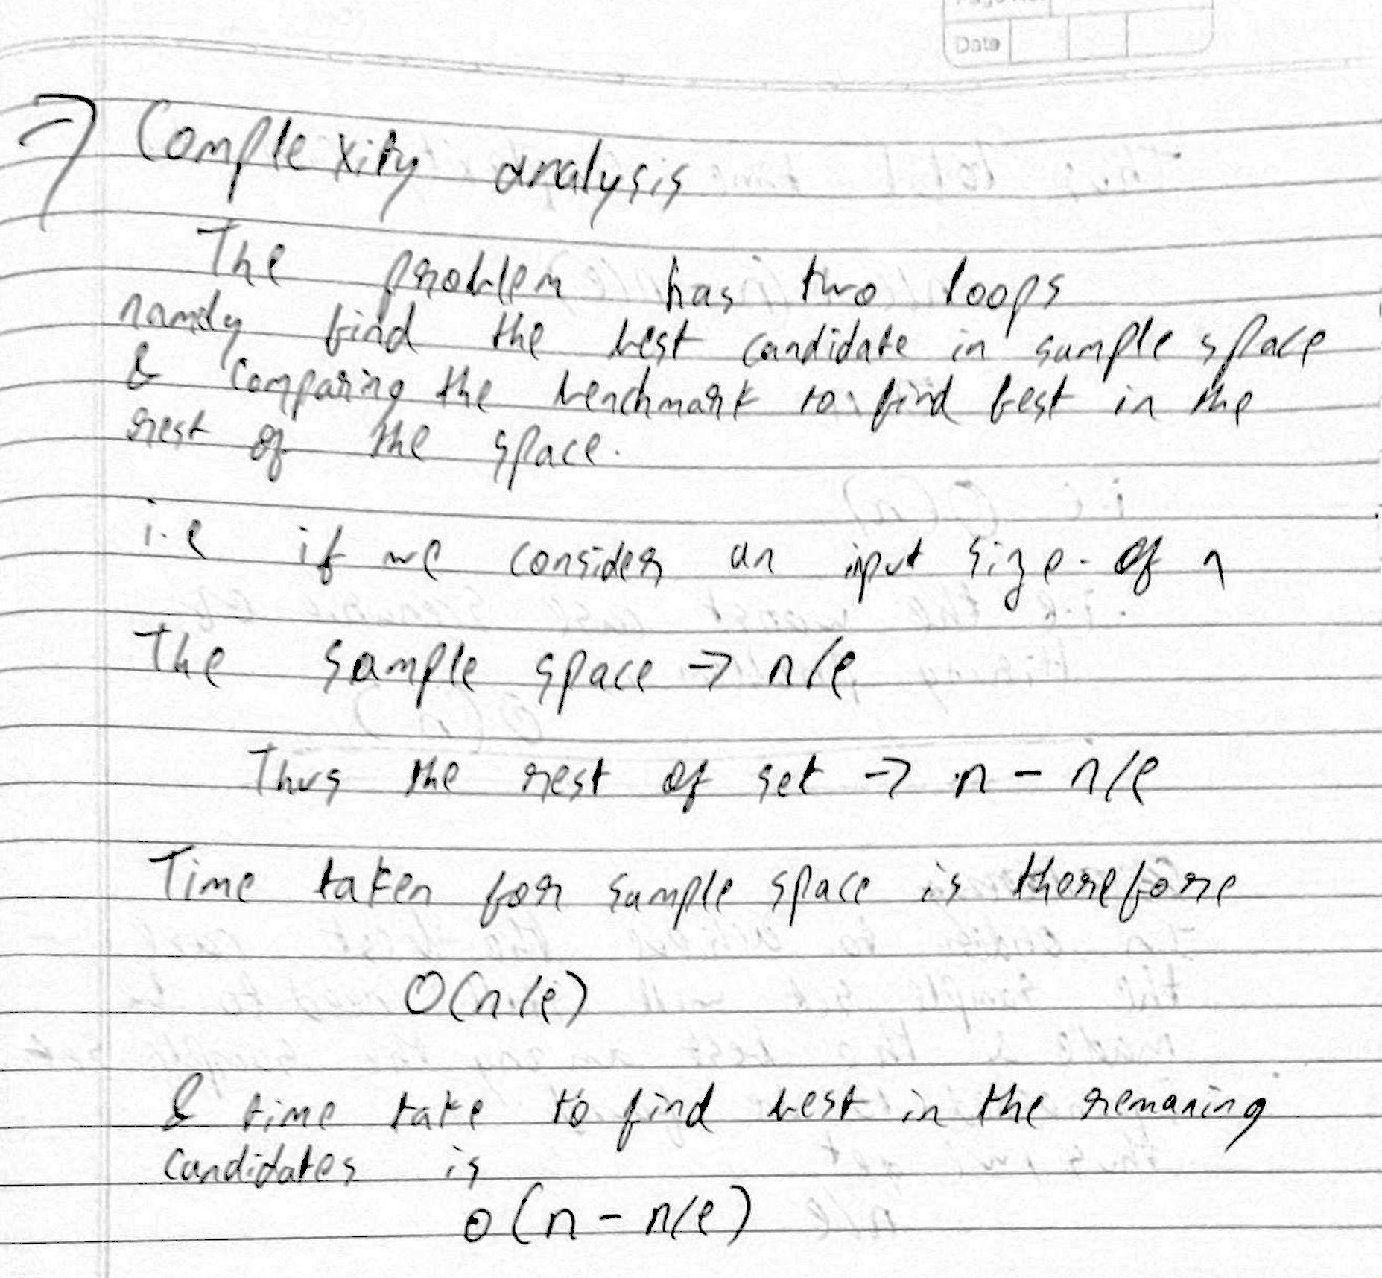

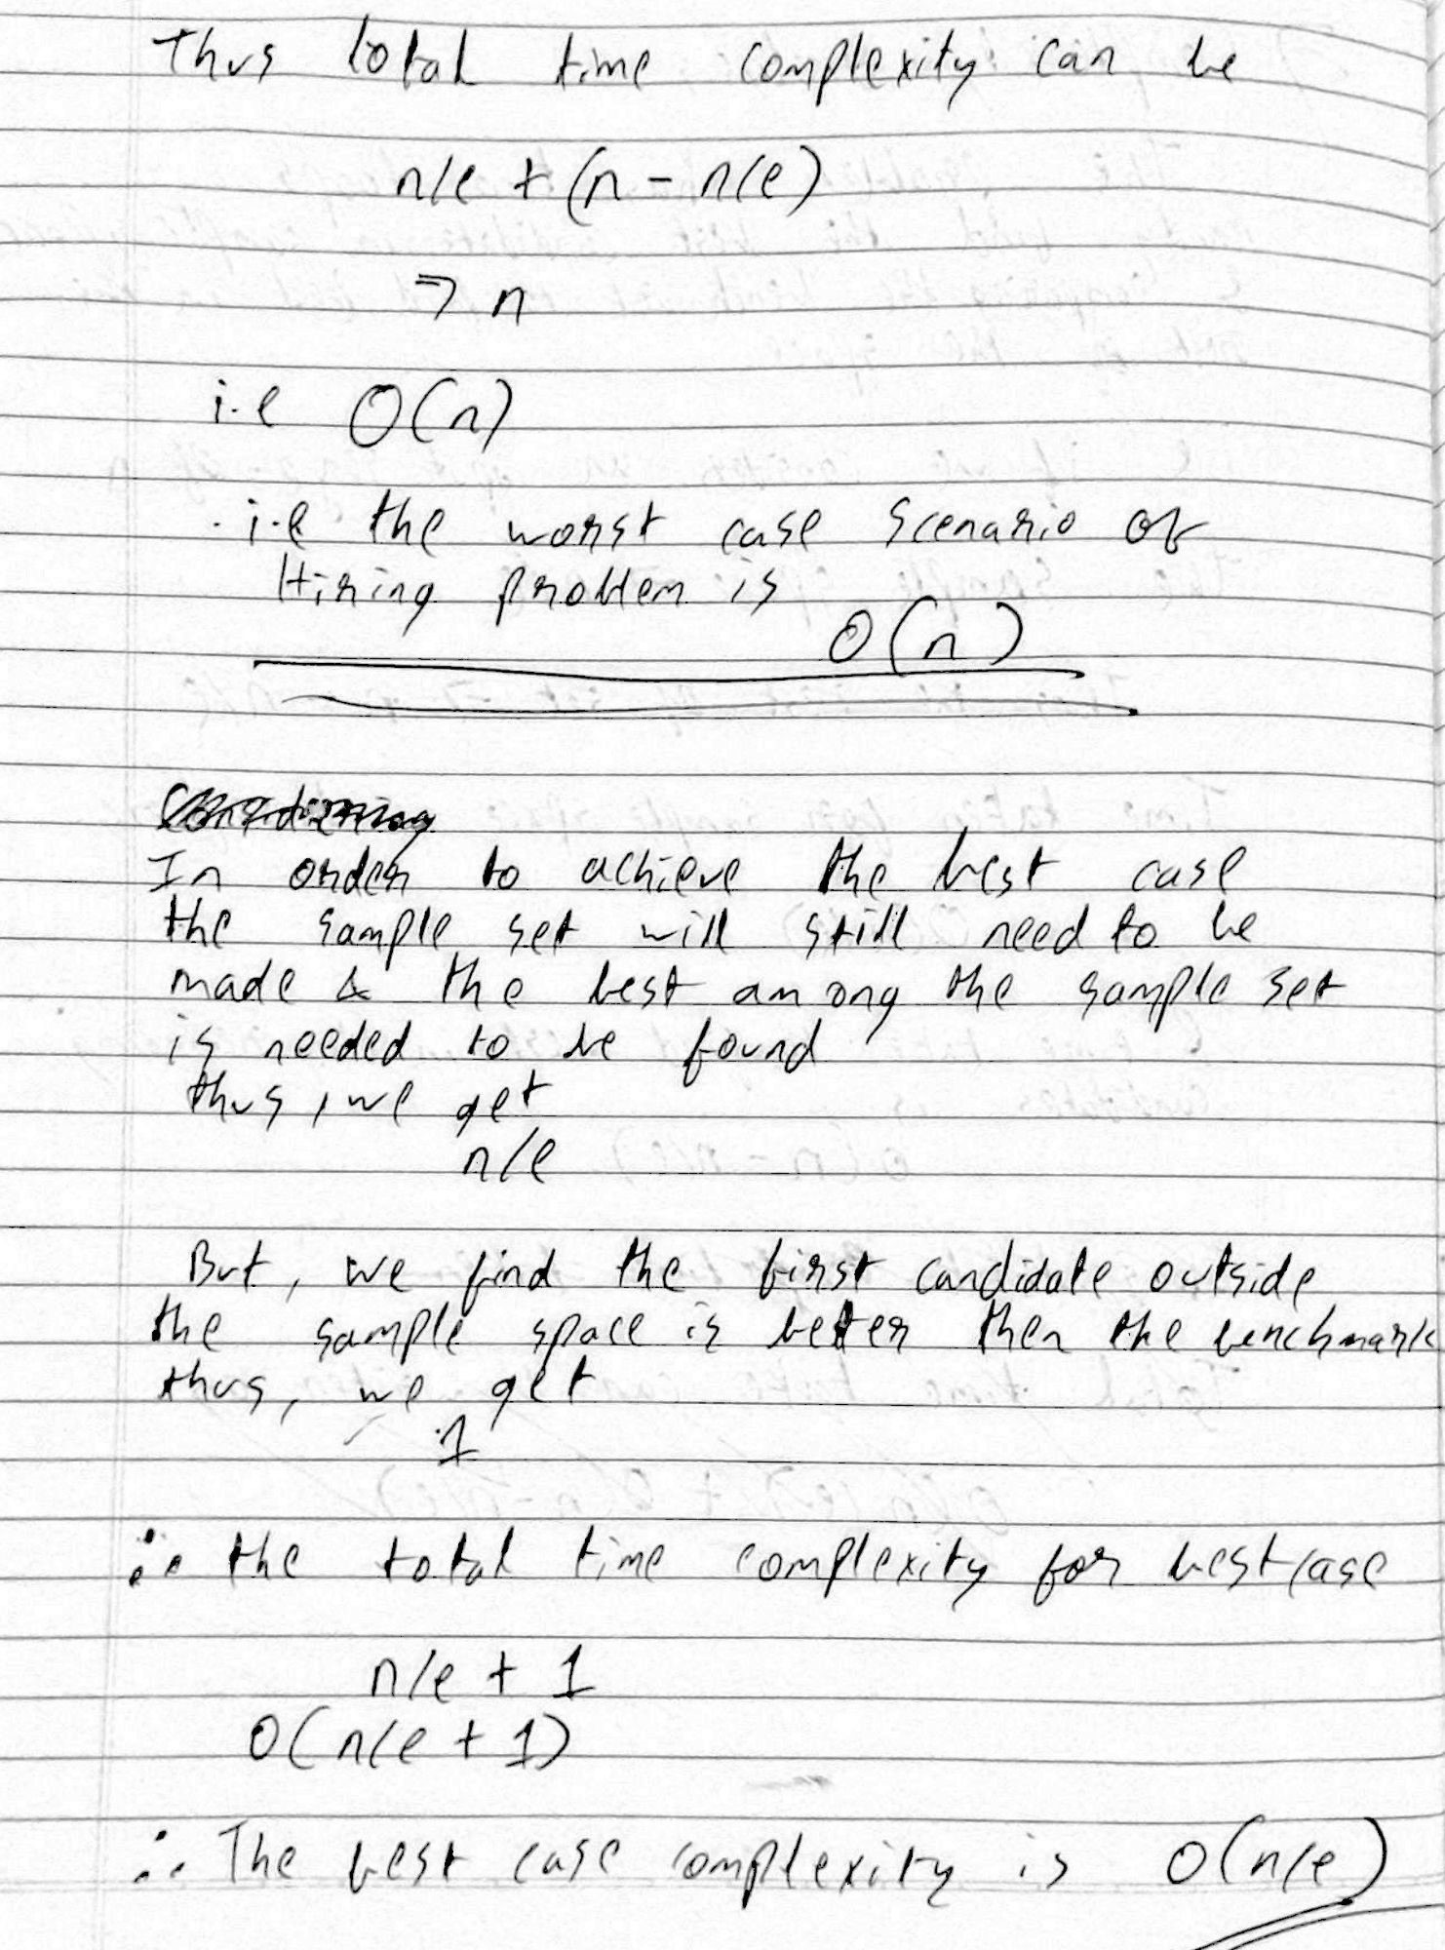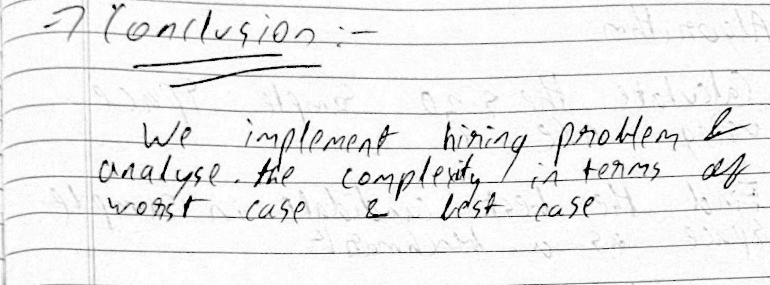

**Program :-**

1. import random
3. def HiringProblem(score, n):
4. sample_size = int(round(n / e))
5. print(f"\nRejecting first {sample_size} candidates as sample")
7. #finding best candidate in the sample set for benchmark
8. best_candidate = 0;
9. for i in range(1, sample_size):
10. if (score[i] > score[best_candidate]):
11. best_candidate = i
13. #finding the first best candidate outside the sample set
14. for i in range(sample_size, n):
15. if (score[i] >= score[best_candidate]):
16. best_candidate = i
17. break
19. if (best_candidate >= int(sample_size)):
20. print(f"\nThe best Candidate found is {best_candidate+1} with score {score[best_candidate]}")
21. else:
22. print("Couldn't find a best candidate")
24. if __name__ == "__main__":
25. e = 2.71828
26. n = int(input("Enter number of candidates to simulate\n"))
27. score = []
28. #populating the list
29. for i in range(n):
30. score.append(random.randint(1, n))
31. print("Candidate\tScore\n");
33. for i in range(n):
34. print(f"{i+1}\t\t{score[i]}");
35. HiringProblem(score, n);

No of candidates = 14

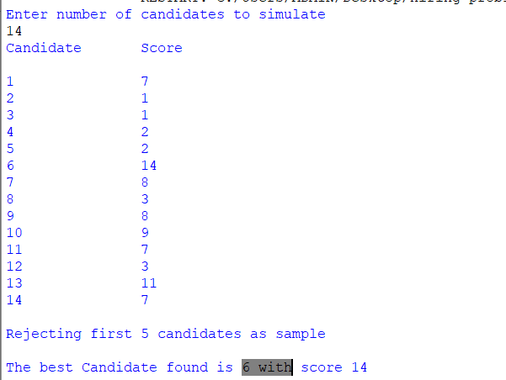

No of candidates = 100

